App Name: b Smart - 1
Feature: User Sign Up/ Login

Registration (Sign Up) Flow
Goal: Create user account
- Select Sign-Up Method
  - Email
  - Phone number
  - Google / Apple / Social login
- Enter User Details
  - Name
  - Email / Phone
  - Password
- OTP / Email Verification
- Accept Terms & Privacy Policy
- Account Created → Success Screen

2. Login Flow
Goal: Secure access
- Enter Email/Phone + Password
- Forgot Password (optional)
  - OTP / Reset link
- Successful Login → Home

3. Profile Setup Flow & Settings
Goal: Personalize experience
- Basic Profile Setup
  - Profile photo
  - Preferences
  - Language / Region ( Default Language + Two Optional Language)
  - Address - complete setup
- Similar settings of Instagram ( review and implement all the required settings )
- Uploaded Videos, Images, Posted Ads
- Wallet & Coins
- Redeem Rewards
- Tools - it contains the app AI features - how the app works like Font, colors, auto reply settings, create own avatar, subscribe for the more additional features… etc
- Help & Support
- Logout / Delete Account

4. Home / Dashboard Flow
Goal: Core app usage

1. Home Header Section
The header of the Home screen includes:
- Profile Icon on the left side
- Search Bar for discovering users, posts, products, or content
- Notifications Icon for alerts, likes, comments, and updates
- Coins / Wallet Icon showing the user’s available coins or balance

2. Home Footer Navigation Bar
The bottom navigation bar contains five main actions:
- Home – Default feed screen ( Similar to Instagram )
- Ads – Advertisements and sponsored content
- + Create – Central action button to create posts, reels, or uploads
- Reels – Short-form video content
- Promoted Products Reels – Product-focused promotional reels

3. Home Dashboard (Main Feed)
The Home Dashboard is the default landing screen after login.
It displays a continuous social feed, similar to Instagram, containing:
- Online People Section
  - Horizontally scrollable list of currently online users
- Followed Users’ Content
  - Posts shared by people the user follows
  - Includes images, videos, reels, and tagged posts
- Tagged & Shared Content
  - Posts where the user is tagged
  - Re-shared content from other users
- General Feed Content
  - Public posts from other users
  - Images, videos, and reels
- Advertisements & Sponsored Posts
  - Native ads blended into the feed
  - Promoted content and product ads

Example Design - UI/UX should be more attractive and User friendly.
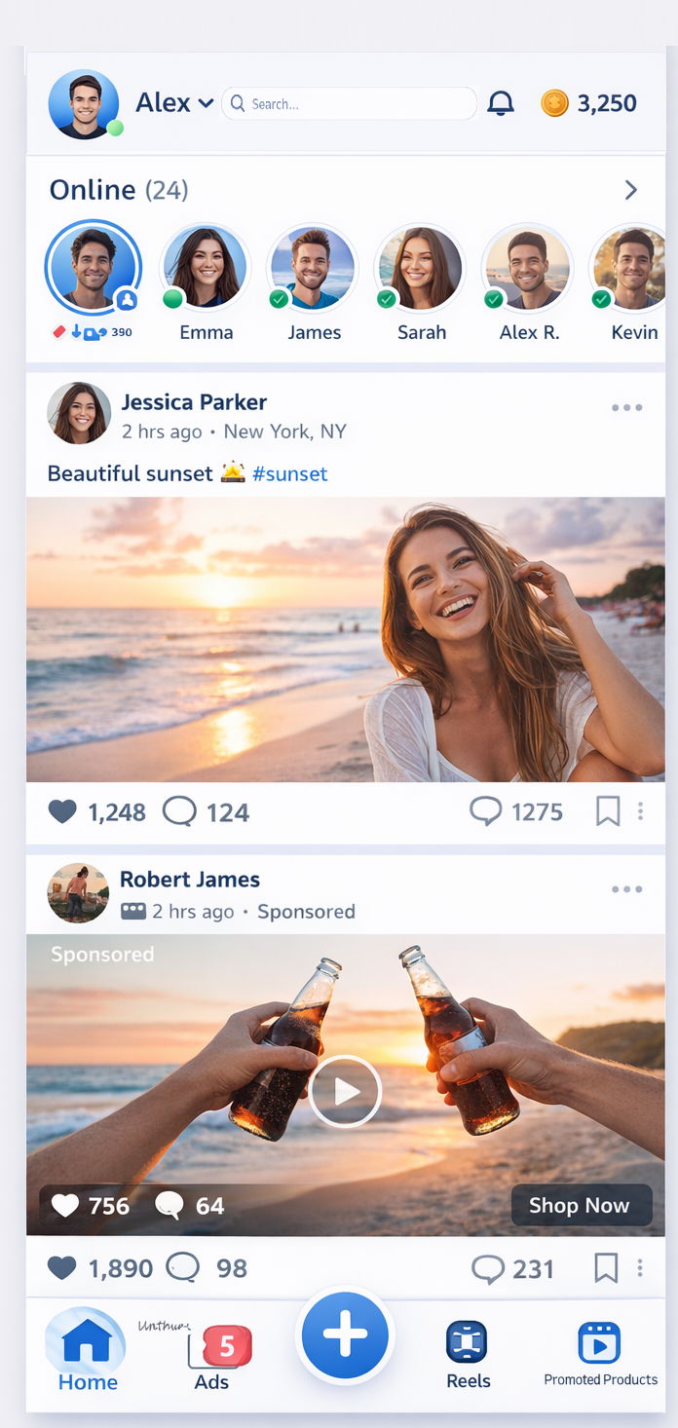

5. Error & Edge Case Flows
Goal: Smooth experience
- No Internet
- Invalid OTP
- Wrong Password
- Session Timeout
- Empty State Screens
6. Exit Flow
Goal: Clean session end
- Logout Confirmation
- Save User State
- Return to Login Screen

